At What Cost?

Missouri Librarians and the Struggle for Intellectual Freedom

Kohlburn, Joe | University of Missouri, US | kohlburnj@missouri.edu

ABSTRACT
Book challenges have a profound impact on communities, but what about the effect these challenges have on librarians? Our pragmatic hybrid approach based on narrative and grounded theory documents librarian perspectives and forms the basis for a broader future investigation of how intellectual freedom work impacts librarians. Interviews with five Missouri public librarians derived from a purposive sample were conducted, and addressed through open and axial coding processes. The results include a code book with 6 major themes and 59 individual child codes, as well as a collection of compelling narratives. The negative impact intellectual freedom challenges have on public librarians is clear. Participants underscore their commitment to the ethics and norms of professional librarianship, but also emphasize the need for more timely support from national organizations and local political structures and the importance of educating governing bodies on the centrality of intellectual freedom to the mission of libraries.

KEYWORDS
intellectual freedom, librarians, mental health, information seeking, narrative

INTRODUCTION
The pandemic brought with it a rise in stressors to parents, teachers, and librarians. It has made relationships more tenuous and navigating already difficult topics like intellectual freedom more fraught. Librarians in Missouri have experienced multiple challenges from parent groups to books and displays that include content for LGBTQ+ and BIPOC readers. Typically, these challenges are framed in terms of “obscenity” or “CRT”, and are the subject of much public and political discourse. Frequently as these challenges escalate to library boards, local government, and the media, librarians are impugned, accused of pedaling pornography, endangering youth and pushing “liberal agendas”. The impact book challenges can have on children, students, and readers is well documented, but what about the impact these challenges have on those who hold intellectual freedom as a personal and professional ethic? Five Missouri public librarians who have each experienced such challenges and worked through them, were interviewed over Zoom. The resulting interviews were transcribed, coded and reassessed based on the resulting codes. Common threads of the narratives of this five-librarian-purposive-sample were distilled and documented as part of living alongside these intellectual freedom advocates in their work.

This pilot study forms the basis for a broader future investigation of how librarians and library workers in Missouri are impacted by intellectual freedom challenges, but to make the findings of this study more relevant to the discourse around intellectual freedom, a hybrid pragmatic methodology was employed for this paper. Clandinin (2013, pp. 34) notes that situating oneself in “more or less relational” ways to participants, and “living alongside” participants as they tell their stories is central to narrative inquiry and allows for a deeper and more meaningful interpretation of these stories. As such, the theoretical underpinnings of this study are two-fold: 1) narrative inquiry, living alongside respondents as they tell stories of struggling with the political, social, and emotional complexities of intellectual freedom work and centering the stories of a small number of participants with whom I work and interact on a regular basis is richer as a result of the my own familiarity with their narratives (Clandinin, 2013); 2) elements of grounded theory are employed in which responses are organized by theme utilizing open and axial coding in order to construct a codebook for future work down the road (Creswell & Poth, 2018). The former being an effort to understand in-depth narratives and experiences of a small number of participants during the process of interviewing and coding, and the latter being an effort to bring to bear this familiarity in service of a broader group of librarians in a later study. The profound nature of the responses of participants was immediately apparent in each interview, and so in-depth narratives are featured prominently below as part of these results in an effort to honor those who contributed their time and energies to this study, and provide a context for a collective debriefing on the past few traumatic pandemic years for all librarians working today. As a result of my tenure in intellectual freedom advocacy in the state of Missouri, I was already familiar with each participant’s story to some extent, prior to the study, and leaned on this familiarity to both work toward a greater understanding of their individual narratives, and provide a richer description of their responses to you the reader. The goal is ultimately to understand how the information seeking and personal well-being of librarians is impacted by intellectual freedom challenges, processes and the political fallout thereof, and to focus on librarians themselves, as they experience confrontations that undermine their autonomy, ethics, and health. Another primary goal is to center the narratives of librarians doing the crucial work of advocating for intellectual freedom in Missouri, a state perpetually in the crosshairs of censorship, especially within the present cultural zeitgeist. In addition to asking participants to tell the stories of their experiences, we ask the following research questions:

RQ 1: How does our contemporary environment of frequent challenges to library collections impact librarians' information seeking behavior as interlocutors on behalf of patrons?

RQ 2: How does our contemporary environment of frequent challenges to library collections impact librarians' personal information seeking behavior?

RQ 3: What factors impact the choices librarians make in responding to challenges?

LITERATURE REVIEW
Shannon Oltmann is a major writer on the impact that intellectual freedom norms have on working librarians (2016; 2017; 2019a; 2019b). Her work focuses generally on library administrators and library workers with MLS degrees (Oltmann 2016; Oltmann 2019a; Oltmann 2019b), and how intellectual freedom impacts the decisions they make in terms of collection development. Her study of fifteen Kentucky library directors uncovered an important distinction: That though directors valued the perception of neutrality, they did not assume that intellectual freedom necessarily meant an uncontroversial collection (Oltmann, 2016). On the contrary, directors suggested that diversity in a collection was what ultimately led to wider access and stronger connections to their communities (Oltmann, 2016). Oltmann (2017) further builds on the importance of diversity in collections, noting the significance of diverse characters represented in literature as a means to promote communal empathy as well as to provide visibility within collections. In her two-part article on Midwestern librarians’ views on intellectual freedom, Oltmann (2019a) describes generally a high degree of support for intellectual freedom among public library workers, which is increased if the respondent has completed an MLS degree. The two 2019 articles represent the culmination of an extensive survey of 645 public librarians in the Midwest around their collection development attitudes and practices with regard to intellectual freedom (Oltmann, 2019a; Oltmann, 2019b). She concludes that local political “leanings” that may be contradictory to professional librarian norms do not have significant impact of the choices librarians make around collection development, counter to anecdotal suggestions found elsewhere (Oltmann, 2019b). She says that librarians from communities with different political majorities were equally likely to support intellectual freedom (2019b). It’s possible that this conclusion has more to do with her interviewing of ALA-accredited credentialed librarians (with an MLS) and their familiarity with intellectual freedom documents than anything else.

Thur (2009) points to the impact that government overreach and sweeping legislation which infringes on intellectual freedom (e.g. The USA PATRIOT Act) can have on libraries and on librarians. Though top-down political threats are a real danger to intellectual freedom standards, Knox (2017) correctly predicts that community pushback against the freedom to read will become the major issue within intellectual freedom conversations in our contemporary context (Johnson, 202l; Grumke, 2021). Reliance on professional organizations like the ALA assumes that such organizations will take meaningful steps to intervene on behalf of librarians (Knox, 2017). Earlier in Knox’s (2014) work, she investigated how intellectual freedom might be supported philosophically through the use of Bourdieu’s idea of symbolic capital. Codification, institutionalization and investigation constitute a three-legged stool of practical philosophy for librarians that along with financial and political support from major organizations like the ALA, has the opportunity to bolster intellectual freedom initiatives, both institutional and grassroots (Knox 2014).

Asato (2014) points to a turbulent history of the ALA’s response to intellectual freedom problems, including issues in the 60s and 70s that eventually led to the establishment of the Office of Intellectual Freedom. Asato (2014) explains that the ALA’s perpetual lack of timely action and confusion about the institution’s purview within its ranks continues to have a negative impact on librarians and the ALA’s ability to effectively impact policy. Though the ALA has provided valuable support to librarians in the form of foundational documents and advocacy platforms, criticism that many of these documents, particularly those that support the idea of “library neutrality” were unduly influenced by administrators and trustees has relevance to the current paper (Asato, 2014). Sieter (2014) supports this finding by pointing out that it is typically grassroots collections of library workers who produce the most meaningful and lasting change within the scope of national institutions like the ALA, and against systemic oppression of various kinds. Librarians’ perceptions of the role that professional organizations play in supporting intellectual freedom likely have a strong bearing on the impact that challenges will have on individual librarians, since substantive support from national organizations may be a critical variable in political and personal outcomes. Though this is beyond the scope of the present study, it may be a relevant trajectory for future inquiry.

Other authors ask simply who defends the defenders of intellectual freedom when professional organizations like the ALA are not willing to take meaningful and bold stances outside the confines of library “neutrality” (Buschman, 2009)? Authors like Buschman (2009) and Sens (2010) point to the impact that lack of organizational support can have on individual librarians, particularly when the ALA fails to take timely action in support of librarians and their choices to defend intellectual freedom. Calls to reconsider the centrality of librarian neutrality in the face of direct challenges to professional and institutional autonomy are central to a reimagining of the role of librarians in intellectual freedom advocacy. Neutrality presents challenges to closely-held values of librarianship like access, privacy, and intellectual freedom (Childs, 2017). Though Childs’ (2017) study is service-focused, her call to restructure the distribution of professional authority to a horizontal model fits with the informal collegial networks librarians maintain through local organizations and list-servs. Gaps in the literature in general are visible in the missing discussions about the impact that intellectual freedom advocacy has on librarians themselves, as opposed to how intellectual freedom impacts the functioning of the library as an institution. This study attempts to uncover a starting point to map the way that librarians are impacted by intellectual freedom challenges and advocacy, and to understand how they might establish better support structures for future efforts to promote intellectual freedom and other professional values.

METHODOLOGY
In order to recognize emergent themes based on the expressed views of five public librarians working in the state of Missouri, this paper employs a pragmatic combination of narrative approach coupled with a social-constructionist coding methodology based in the ideas of grounded theory (Clandinin, 2013; Creswell & Creswell 2018, pp. 203-210; Creswell & Poth, 2018). After IRB approval, a purposive sample of five subjects was selected based on the subjects’ previous experience with intellectual freedom advocacy as well as their positions as leaders or managers at public libraries in Missouri. Each participant was given 9 broad questions (Table 1) in semi-structured interviews carried out over Zoom. In the interview, participants were asked to describe how their behavior around finding information for patrons or colleagues has changed due to the pressure and added stressors that the political environment around book challenges has caused. Participants were asked to describe job satisfaction, experience with intellectual freedom advocacy, as well as ideas for changes they would like to see to institutional interactions between librarians and the public. Participants were also asked a series of questions about Missouri’s political climate, and how it impacts their work, as well as to describe how such anxiety has influenced their own personal information seeking behaviors and job satisfaction. Participants were assigned a code number that corresponds to their name on an offline password-protected spreadsheet for safe record-keeping. All informants’ responses were anonymized and coded thematically. Where quotes are used, identifying information was removed.

Has your experience and job satisfaction as a library professional changed since you started your career? How?
How would you describe Missouri’s political climate as it impacts librarians in their everyday work? Explain?
Do you think Missouri’s political climate, as you’ve described it, has impacted you? Please explain.
Do you think Missouri’s political climate has impacted the way you provide service to patrons? For example, do you find yourself second-guessing recommendations with content that might be found objectionable or might be challenged by parents? Explain.
Do you find that Missouri’s political climate has in some way impacted your own information seeking behaviors? Explain.
Can you tell me a little about your experience as a librarian with intellectual freedom challenges? This would include book challenges, but could be so broad as to include other intellectual freedom concerns like privacy or access. Have you had personal experiences with book challenges or challenges from community members to your collections or the way you perform your professional duties?
If so, how has this impacted your job satisfaction, if at all? How has it impacted the way you perform your job, if at all?
What changes, if any, would you like to see to the way librarians and the general public interact in terms of collections and policy?
Tell me a story about intellectual freedom that illuminates your experience.

Table 1. Interview Questions
The recorded zoom interviews were saved to the cloud, and responses were transcribed automatically. Then, the transcriptions were moved to a secure offline location, with online files subsequently being deleted to protect confidentiality. Transcripts for each of the five participants were read multiple times looking for common or significant themes that might illuminate how participants information seeking behavior on behalf of patrons changed, or how their own information seeking behaviors were impacted by the threat of intellectual freedom challenges either in their own library, or in Missouri more broadly. 52 codes were identified in open coding and were arranged into six broad categories during the second stage -axial coding (Creswell and Poth, 2018). A preliminary simple codebook was created with the following main categories: political climate, information seeking, intellectual freedom, jobs and roles, sources of harm, and librarians value (Creswell & Creswell, 2018). The codes from open coding were then nested beneath one of these six categories. Transcripts were then loaded into NVivo 12 along with the codebook. As the transcripts were read through again and marked up using the codebook in NVivo 12, 7 new child codes were added as connections and patterns crystalized in the data. For example, under challenges, further child codes were added based on responses that discussed particular hot-button political issues like the pandemic, extremism, and LGBTQ+ rights. Transcripts were also coded based on which question respondents were answering (see above) so that they could be cross-referenced with significant themes to demonstrate patterns within individual questions across all respondents.

Since only five respondents were interviewed for this exploratory pilot study, response frequency was only determined to get some idea if given codes were appropriate. The results give some idea of a general direction that a larger collection of data might take. That said, it should be noted that this pilot study is purely exploratory, since five participants is not sufficient to reach any sort of threshold for broader applicability from a grounded theory perspective. The codebook produced by this pilot will be used as a tool to make sense of a larger cohort of participants in a future paper. The extensive responses of the participants to the ninth question in particular rendered expansive insight based on the extent of the narrative focus on things like trauma, stress, and harm, which gives us a sense of patterns that might be present in a broader population from a narrative inquiry perspective.

FINDINGS
In total, the interview transcripts for the five participants were coded for 59 distinct codes, with 6 overarching themes: information seeking, intellectual freedom, jobs and roles, librarians value, political climate, and sources of harm. A complete map of participant responses reveals the frequency of specific codes as well as their relationship to the aforementioned overarching themes (see Figure 1.)
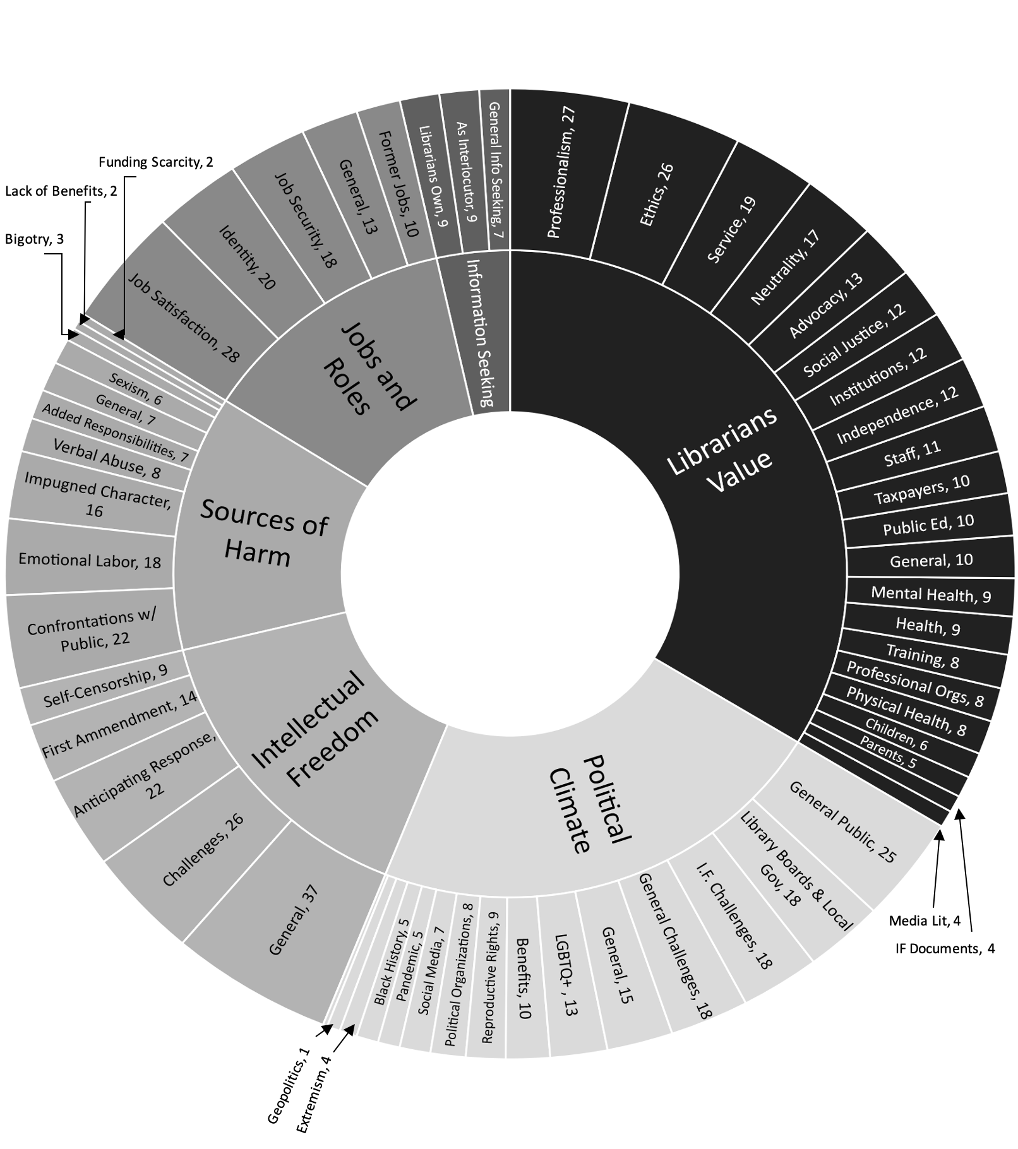

Figure 1. Code Distribution and Relationships

Impact on Information Behavior as Interlocutor
All participants expressed an awareness of professional norms around their roles as interlocutors for library patrons. Participants who expressed their regret at diverging from those norms of neutrality or professionalism described their efforts to correct their behavior to meet norms. Participants who described the dangers of diverging from norms of neutrality described extensive deliberative and anticipatory activities to have a prepared response for any community pushback against displays or other professional choices: ‘Let’s try and think through as many possible negative reactions as we might have so we can line up some talking points, […] ahead of time to have a conversation with somebody comes in.’ (Participant 1). Other participants expressed the importance of professional norms, and their earnest adherence to these norms with clear if understated responses. When asked if Missouri’s political climate (often hostile to intellectual freedom advocacy) influenced the quality of service to their community, Participant 4 replied, ‘ No…. It doesn’t’. Within the context of the interview, this was clearly meant as an indication of Participant 4’s strong belief in the core tenets of professional service.

Impact on Personal Information Behavior
Based on their descriptions of Missouri’s political climate, all participants expressed a change in their own information seeking over the course of their careers as librarians. All in some way pointed to their information seeking around political and social issues as having changed, with Participant 1 going so far as to trace the change to a political awakening caused by the election of Donald Trump in 2016. Participant 2 pointed to personal information seeking leading back into professional information infrastructures in an effort to understand best practices and policies of other libraries that were dealing with intellectual freedom issues.

And what I’ve found myself doing is I’ve been looking at a lot of sources that are outside of libraries, especially for like board governance and guidance for boards and directors in general. So I’ve been looking outside of libraries for that, which isn't bad, but I think that the library profession is a unique profession[…] (Participant 2)

Participants 3 and 4 pointed to information seeking changes around media literacy and news consumption as having shifted as a result of Missouri’s political climate. Participant 4 mentioned the dangers of clickbait and feeling a responsibility to prevent the spread of misinformation or disinformation. Participant 3 points to the detrimental impact of constantly watching distressing news reports or reading news articles can have on the reader’s mental health.

I feel like I’m trying to be more informed, but at the same time being informed is also like kind of detrimental to your mental health[…] It’s sometimes easier, just to find something that's happy as opposed to what's actually happening in reality, because you can only take so much negativity before it's just it affects everything. (Participant 3)

Choices and Changes in Intellectual Freedom Responses
When asked how their experiences changed the way they dealt with intellectual freedom issues, participants indicated increased anticipation of public responses and occasional self-censorship. All participants mentioned self-censorship in some form, with participants 1 and 2 describing extensive preparatory efforts to prepare for push back against displays or collections, while participant 3 admitted to sometimes not acquiring a book because of potential complaints from patrons. Participant 5 described deliberately looking for books with LGBTQ+ or BIPOC characters in an effort to create a more inclusive collection. Participant 5 also deliberately tried to provide access to important information on topics like sex education. Participant 4, as noted earlier, replied simply that they were not engaging in self-censorship at all. Most mentioned in some capacity the influence that governing bodies had on the decisions that ultimately were made around intellectual freedom challenges.

In response to a question about what changes they would like to see in how the public and local officials interact with librarians, participants 2, 3, 4, and 5 immediately mentioned their boards. All five participants had extensive experience as public librarians, all worked under a governing structure with some kind of board of directors that oversaw the work of the library director or library administration. Participant 1’s recent negative experience with a “first amendment auditor”, and lack of support from their board may have contributed to them not mentioning this governing structure directly. Participant 2 was in the midst of a book challenge that had made local news, and recently experienced staff and administrative turnover as a direct result of this challenge. Participant 2 expressed a need to involve the community of supporters more closely in the process of library governance at the board level, mentioning the counterproductive impact that dealing with oppositional public groups and extremists was having on the library as an institution:

It has led to all kinds of things that I’m constantly looking over my shoulder double-checking. racking up literally thousands of dollars in attorney fees that's taxpayer paid for, to make sure that we're doing everything right. Oh oh, and we have security at all of our board meetings now because we had a couple of people who were yelling insults and threatening the board.

One respondent (Participant 2) went on to describe a need for board and public education around the purpose of libraries as points of access for information, not as partisan organizations, or spaces for political grandstanding. Another participant pointed to the unreliable funding politics in the state of Missouri as being a source of stress for librarians, and as undermining libraries as institutions:

I feel like every time we advocate for funding and for support and things like that, all that goes really well and we are promised, you know, lots of support and that actually never ends up following through, right? That it gets shoved off a desk somewhere or whatever, and where we're fed, you know, the measly little pieces. (Participant 4)

Participants 3 and 5 pointed to good working relationships with their boards. They praised their board members’ understanding of intellectual freedom and the trust that the board placed in them as professionals as key to feeling empowered to work through difficult situations. Participant 5 most clearly expressed the general sentiment shared by all five participants, Participant 5 said:

What I would want any library board to know and to feel is how my board treated the request to pull a book: And that is if you're hiring somebody, […] You trust them to know what they're doing and to want to spend tax dollars wisely, and to have the skills to know what [to] purchase for the community.

Change in Job Satisfaction and Personal Wellbeing
All those interviewed expressed detrimental impacts of having to deal with either direct book challenges, first amendment challenges, or the political environment of the state of Missouri as it related to intellectual freedom. All five participants discussed emotional labor as taking a toll on their job satisfaction and mental health, some fearing that advocating for professional ethics would paradoxically endanger their employment as librarians.

I mean, I still love what I do, but man it's getting a lot harder to go to work every day. I am now going to work, you know I feel like I am defending the library, like this is my battle, and it feels very personal because my values and my principles align with like the library profession’s, so it makes it harder to go to work. (Participant 2)

All five valued mental health and described specific issues that were negatively impacting their own mental health or that of their staff. Two described intellectual freedom issues at their own libraries, one participant mentioned the discussion on professional list-servs about potential challenges, and one expressed exasperation with the political climate in general and an interest in finding less stressful work. For some, this stress has had very real impacts on their physical health. Participant 2 says:

It's exceptionally stressful. I don't know how people do it on a regular and sustained basis because, in just this calendar year alone, I have been in the ER twice for stress related things, and it's the only thing in my life that's stressing me out, and I mean I’ve got a Scrooge-McDuck-sized amount of student loans, and that doesn't even stress me out like this is. This is the source of all of my stress and it's taking all of my real estate in my body and my mind, yeah, so it's really hard to switch it off when I go home.

Participant 4 linked their own identity as a member of the LGBTQ+ community to an increased sense of empathy and understanding for “the other” within the context of access and inclusion. They suggested that this was a major reason that intellectual freedom and access was important, and described the impact that challenges had on their personal state of mind with respect to personal and professional identity.

I think that that's a rough one, because that has been one of the pervasive issues with my own system, right? Um I think that, especially when the [challenge] happened. When you know people started complaining about a health, education and experience program given by someone who was a trans person, and who was simply trying to share an experience and simply trying to, I don't know, help family members and friends who had trans people in their lives understand better and have a different perspective on it. When that was shut down, I think it affected me. I think it affected many people around the system. That and again the communication was that we don't value this, and not only that, but we are going to invalidate this. We are going to invalidate you as a people. And the problem is… this is going to sound terrible but, people who have never been “other” do not understand the impact that has. They don't understand the impact that being “other” has on people, and they don't understand the impact that they have on people when they devalue or dehumanize them. They will never, you know, even if they were to become an ally. I don't know that they would be able to understand what that does to you right? I mean me, thankfully, I’m, you know, I’m a person that fights it, but not very many people who have real trauma, because of that, do.

Code Distributions
As mentioned above, the low number of participants in this purposive sample precludes making any broad extrapolations from the responses based on the frequency of applied codes. While the results are primarily useful to create a codebook for future studies in the context of the codebook, some interesting nascent indications can be pulled from those responses that were coded for all five individuals. NVivo 12 allows researchers to look at not simply how often a code like “social justice” or “ethics” was used, but also at how widely it was distributed throughout each transcript. Looking at results that were coded for all five respondents, we can see that certain child-codes like book challenges were coded for all five participants and were fairly widely distributed as we might expect given the nature of the interview. Other codes that were present for all five respondents followed more surprising patterns of distribution. For example, the anticipating response child code under intellectual freedom was used to denote librarians worrying about community response to programs, choices, or collections before specific responses had been received. We can see from the distribution of this code across all five respondents’ interviews that although all five mentioned anticipating community response, for participant 1 and 3, this anticipation made up a much more significant portion of their interview than participant 4. This frequency potentially reflects individual temperament or concerns, while the fact that all five participants mentioned this idea at least a couple times indicates the impact of professional norms as distributed via education, professional organizations, and informal networks (as in Figure. 2).

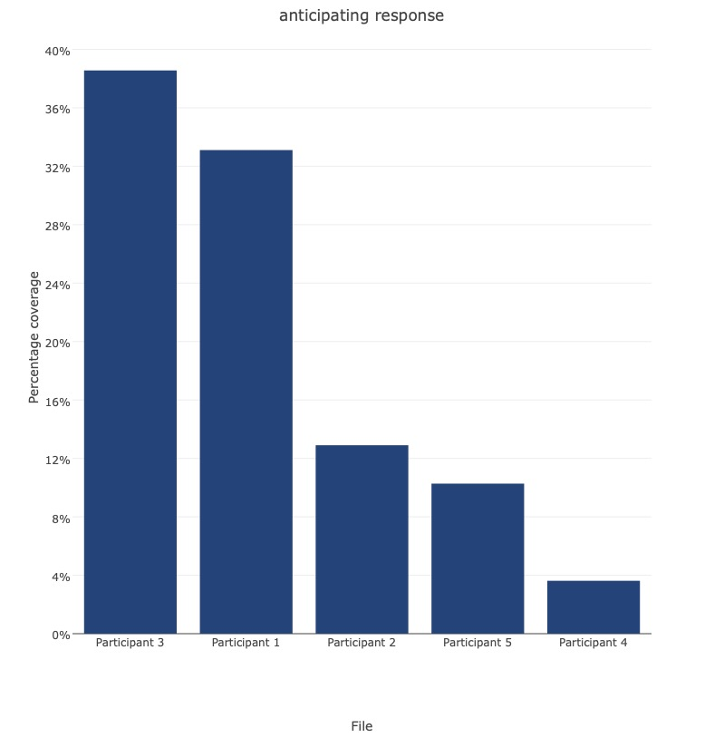
Figure 2. Anticipating Response Code Distribution
Finally, this trend is again evident in how recently a participant has had an intellectual freedom challenge of some kind in their own library. Though some participants were more sanguine about their experiences with the general public, even if they were clearly quite traumatic, others took the occasion of the interview as a chance to unpack recent trauma. Participant 1, for example, had recently had a so-called “first-amendment auditor” at their library. The event was featured prominent in the participant’s narrative, and professional norms and expectations required a degree of emotional labor that ultimately took a toll on the participant.
I am tired of having the same conversation over and over and over again with the public […]. And having to defend libraries, day in and day out does get a little taxing. It is mentally and emotionally draining to you know, have to fight for your profession, or even just fight for people to understand that just because we have a book on our shelves doesn't mean that the librarians are predators, who are grooming your children, for you know… “to be molested” and that, unfortunately, is real commentary coming from community members about some of the library materials. So just trying to justify my existence as a decent person sometimes is what has to happen, and that can get very, very draining and very taxing.

One sees in Participant 1’s response indications of burnout and signs of exasperation with the views of the general public, as well as the extreme rhetoric within public discourse, wherein librarians are compared to ‘predators’ merely for providing access to children’s materials in their library collections. The distribution of the code “emotional labor” across Participant 1’s responses demonstrates the degree of ‘space’ that the event takes up in their accounting of the scope of intellectual freedom as a topic within the interview (see Figure 3).

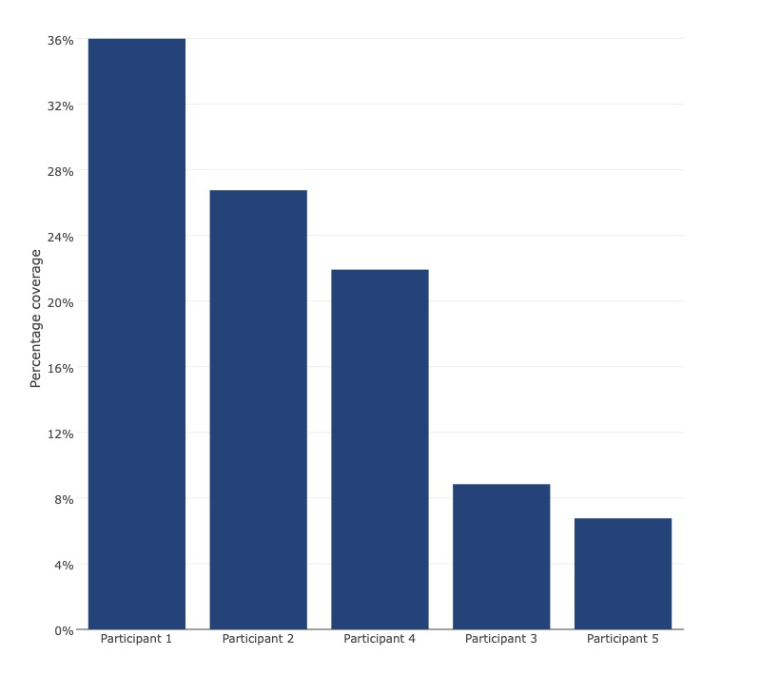
Figure 3. Emotional Labor Code Distribution

DISCUSSION
Initial indications from these five interviews suggest that librarians experience a deep alignment between their personal and professional convictions about the importance of intellectual freedom. This has both potentially positive and negative implications for individual librarians in terms of job satisfaction, job security, and their reported outcomes in terms of mental and physical health. Librarians express the harm caused by negative interactions with the general public, especially when their own integrity and professionalism are impugned. Though Oltmann’s (2019b) findings suggest that political environments do not significantly impact librarian choices in terms of collection development, our preliminary interviews suggest that librarians are greatly impacted by the political environment in which they find themselves. Librarians further express the harm caused by boards and local governments undermining the application of intellectual freedom values and norms to the practice of librarianship. Librarians maintain a robust adherence to professional norms in the service of their patrons, agreeing unanimously (in this study) that their information seeking on behalf of patrons was not changed or curtailed, although most described added anxiety around collection development or programming.

In librarians’ own information seeking behavior, respondents emphasized the importance of media literacy to understanding current events and contextualizing intellectual freedom within Missouri’s local political climate as well as nationally. Participants expressed the necessity of having well-informed boards, steeped in the values of librarianship, who trust librarians to do their jobs without undue intervention or interference, and expressed a deep commitment to providing access to materials, as well as to providing a safe environment for patrons from diverse populations, children, and the community in general. All five participants valued ethics, intellectual freedom, service, social justice, and professionalism. All also recognized the importance of professional organizations like the ALA, but not all participants mentioned national organizations in a positive light, reflecting Asato’s (2014) assertion that the ALA is frequently slow to act, and acts in ways that are not always beneficial to librarians in their local contexts. As the literature outlines, the importance of organizations like the ALA is directly related to how well it responds to the needs of librarians (Knox, 2017; Thur, 2009 ; Asato, 2014). Informal and local connections were also frequently part of the stories that participants told. These networks are sources of information and solidarity on issues of intellectual freedom, particularly during the global COVID-19 pandemic. This reinforces Childs’ (2017) research that underlines the importance of local and informal networks as well as grassroots professional and political coalitions to move policy forward in such a way that librarians are supported. As Oltmann (2016) emphasizes, even librarians who adhere to norms of neutrality recognize the need for diverse collections featuring LGBTQ+ and BIPOC characters, which invite challenges like those common to Missouri Libraries over the past few years (Johnson, 202l; Grumke, 2021; Musa, 2022). The stories that respondents told throughout these five interviews were frequently idiosyncratic based on the participant’s relationship to their particular board, or their luck with media and specific challenges. That said, significant commonalities emerged that go beyond just a common set of professional ethics and norms. As such, in addition to our own efforts, greater understanding of librarians’ experience could be reached through in-depth phenomenological studies aimed at uncovering emergent properties of experiences with intellectual freedom and professional practice (Creswell & Poth, 2018).

LIMITATIONS
This pilot study is intended to establish a codebook and get an initial orientation for a more robust investigation of the impact of intellectual freedom advocacy on public librarians. The narratives conveyed herein are the more substantive contribution to the field at this stage than are the resulting codes and codebook. The pragmatic method employed for this study neither strictly follows the prescribed path of narrative inquiry nor grounded theory, and so may lack the more clearly mapped contexts of each respective track when strictly applied. The sample for this paper was drawn from my own list of friends and acquaintances, some of whom I work alongside. As such, the sample is neither representative of the general population of librarians in Missouri, nor able to provide much more than the aforementioned orientation for future investigation and in-depth narratives to serve as guideposts for future inquiry.

CONCLUSION
Previous research focuses on the impact of intellectual freedom challenges on communities, and the individual rights of librarians, but fails to account for the impact that dealing with intellectual freedom challenges has on librarians professionally and personally. As workers, librarians suffer the same stressors that other front-line laborers in related service professions do, as made yet more evident by the pandemic (Parker & Clark, 2022). Additionally, librarians are faced with surmounting expectations for emotional and intellectual labor in the face of challenges to intellectual freedom and other civil liberties. Understanding the impact of these stressors can help produce mitigating strategies to retain librarians in the sphere of public libraries as well as support librarians in their work to advocate for intellectual freedom. This study produced a codebook with six major themes, and 59 specific child codes that will help describe the interconnectedness of concerns about intellectual freedom and librarian well-being. It also produced a collection of five richly-rendered narratives from dedicated professionals working to protect the intellectual freedom of their patrons. In future studies, the codebook might be used and amended to reflect the experiences of a larger more representative sample of librarians in the state of Missouri, or nationally.

ACKNOWLEDGEMENTS
I would like to thank the five participants in this study who generously gave of their time and energies, and at times revisited recent trauma to clarify and put forward their experiences for greater visibility in the literature. I would also like to thank my colleague and fellow doctoral student, Hillary Gould for helping me with data visualization, she came up with figure 1, the starburst graph above. Her excel skills are unmatched.

REFERENCES
Asato, N. (2014). Librarians’ free apeech: The challenge of librarians’ own intellectual freedom to the American Library Association, 1946–2007. Library Trends, 63(1), 75–105. https://doi.org/10.1353/lib.2014.0025
Buschman, John. (2009). Who defends intellectual freedom for librarians? Academe, 15-17. http://www.aaup.org/AAUP/pubsres/academe/2009/SO/Feat/busc.htm
Childs, L. (2017). To uphold and resist: Protecting intellectual freedom through progressive librarianship. The Serials Librarian, 73(1), 58–67. https://doi.org/10.1080/0361526X.2016.1270248
Clandinin, D.J. (2013). Engaging in narrative inquiry. New York, NY: Routledge.
Creswell, J.W., and Creswell, J.D. (2018). Research design: Qualitative, quantitative, and mixed methods approaches. 5th Ed. Los Angeles, CA: Sage.
Creswell, J.W., and Poth, C.N. (2018). Qualitative inquiry & research design: Choosing among five approaches. 4th Ed. Los Angeles, CA: Sage.
Grumke, K. (2021, Nov 18). Schools across St. Louis face more attempts to remove books from library shelves. St. Louis Public Radio. https://news.stlpublicradio.org/education/2021-11-18/schools-across-st-louis-face-more-attempts-to-remove-books-from-library-shelves
Johnson, B. (2021, Sep 22). Protesters in Cass County say the public library must remove children’s book. KMBC News. https://www.kmbc.com/article/protesters-in-cass-county-say-library-must-get-rid-of-a-childrens-book/37683653#
Knox, E. J. M. (2014). Supporting intellectual freedom: Symbolic capital and practical philosophy in librarianship. The Library Quarterly, 84(1), 8–21. https://doi.org/10.1086/674033
Knox, E. J. M. (2017). Opposing censorship in difficult times. The Library Quarterly, 87(3), 268–276. https://doi.org/10.1086/692304
Musa, Amanda. (2022, Feb 18). Two students and ACLU sue Missouri school district over removing 8 books from libraries. CNN. https://www.cnn.com/2022/02/18/us/missouri-aclu-banned-books-lawsuit/index.html
Oltmann, S. M. (2016). For all the people: Public library directors interpret intellectual freedom. The Library Quarterly, 86(3), 290–312. https://doi.org/10.1086/686675
Oltmann, S. (2017). Creating space at the table: Intellectual freedom can bolster diverse voices. The Library Quarterly, 87(4), 410–418. https://doi.org/10.1086/693494
Oltmann, S. M. (2019). Important factors in midwestern public librarians’ views on intellectual freedom and collection development: Part 1. The Library Quarterly, 89(1), 2–15. https://doi.org/10.1086/700659
Oltmann, S. M. (2019). Important factors in midwestern public librarians’ views on intellectual freedom and collection development: Part 2. The Library Quarterly, 89(2), 156–172.
https://doi.org/10.1086/702203
Parker, R., & Clark, B. Y. (2022). Unraveling the great resignation: Impacts of the COVID-19 pandemic on oregon workers. SSRN Electronic Journal. https://doi.org/10.2139/ssrn.4019586
Seiter, A. (2020). Libraries, power, and justice: Toward a socioculturally informed intellectual freedom. The Progressive Librarian 47, 107-117. https://nrs.harvard.edu/URN-3:HUL.INSTREPOS:37366973
Sens, J.-M. (2010). “Not I” said the pig: Who defends intellectual freedom for librarians? Library Philosophy and Practice.https://link.gale.com/apps/doc/A241615973/AONE?u=anon~4f9224fb&sid=googleScholar&xid=40389b8e
Thur, V. L. (2009). War, law, and the librarian: The creation, precedence, and passage of the USA PATRIOT Act and its effects on libraries. Journal of Access Services, 6(4), 437–445. https://doi.org/10.1080/15367960903098838

